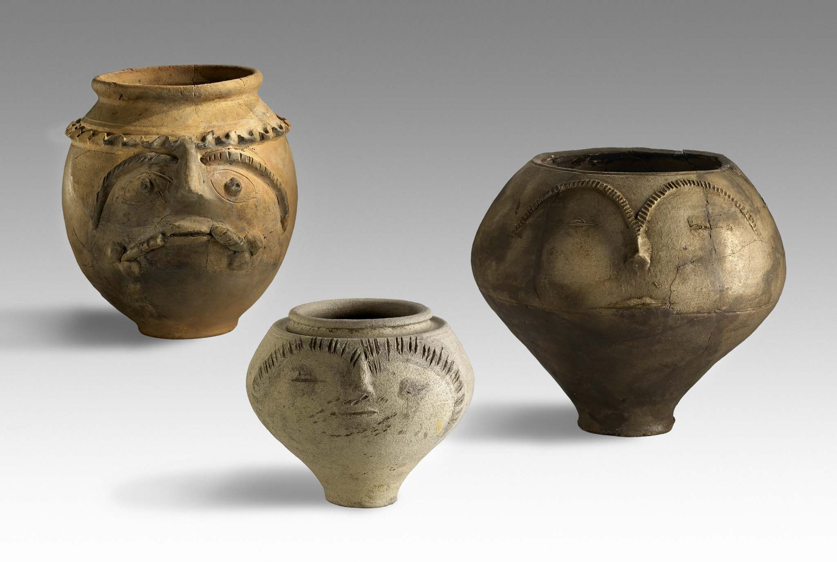
Post-Congress Tour

27th September 2014
Cologne

29th Congress of the Rei Cretariae Romanae Fautores

Xanten, Germany, 21st – 26th September 2014

Dear Fautores, friends and colleagues,

please take notice of the new information about the post-congress tour to Cologne.

Preliminary programme

Departure from Xanten will be at about 7 am.
Arrival in Cologne is expected to be at 9 am. As the Museum opens at 10 am there will be time for a visit of the Cologne Cathedral (no guided tour).

At 10 am there will be a short welcoming at the Römisch-Germanisches Museum. Guided tours (in English, Italian and German) through the museum are planned.
The Römisch-Germanisches Museum of Cologne stands on the walls of a Roman villa in which the famous Dionysos mosaic was found. It accomodates exhibits of Roman and Early Medieval Cologne, amongst the reconstructed monumental Tomb of Poblicius and one of the world’s most important collections of Roman glass. In several floors the development of the capital of the province Germania inferior, Colonia Claudia Ara Agrippinensium, is shown.

A highlight is the special exhibition „14 AD“ for the 2000th anniversary of the death of Augustus. The entry fee for this exhibition is included in the tour fee, but there will be no guided tour. You are of course free to walk through the exhibition on your own.

The lunch break will be hosted in a typical Cologne brewery inn.

After the lunchbreak guided tours through the excavations below the Cathedral and the Praetorium are on our list (tours may be arranged in English and German).
The excavations below the Cathedral comprise the early beginnings of the Christian community in Cologne during the Late Roman times as well as the medieval predecessor buildings of the Gothic Cathedral.

The Praetorium, the Roman City Hall, was the seat of the province governor. The tour will lead to the monumental walls of the 4th c. AD and the Roman Sewer, which is accessible on a length of 150m.

Return to Xanten is approximately at 6 pm. The return can be arranged flexibly. The busses will definitely return to Xanten and a stop at Düsseldorf can be arranged for those who wish to return to their hometowns from the airport in Düsseldorf.
Of course you have also the opportunity to stay in Cologne and Düsseldorf, if you want to extend your stay there. To enable you to organize your stay more flexible, we kindly advice you to arrange your accomodation according to your plans.
Please understand that we can’t lower the fee for those who are not returning to Xanten as the expenses for the busses include both ways.

The following link leads to the tourist informations in Cologne and Düsseldorf, for those who are planning a longer stay there:

http://www.cologne-tourism.com/
http://www.duesseldorf-tourismus.de/en/tourist-information-offices/

Post-Congress Tour Fee

The fee is expected to be 80 – 95 € per person. The fee depends on the number of participants as the number of busses and tours will be accordingly. The fee includes: transfer from Xanten to Cologne and back, lunch, guided tours and entry fees.
The final fee will be announced in the Third Circular in April with the payment details.

Deadline for payment will be the 15th June 2014. The fee will not be repaid for cancellations after that date!
If the Organization Team hasn’t received payment by 15th June 2014, the participant will be removed from the excursion list!

Registration

If you intend to join the post-congress tour please confirm your attendance by sending an email to the Organization Team (RCRF-29.APX@lvr.de). Please give information about your return wishes (return to Xanten, stay in Cologne, getting off/stay in Düsseldorf).
The deadline for binding registration for the post-congress tour is 31st May 2014. After that date all those who haven’t given any notice will be removed from the list!

General information

If you intend to stay in Cologne or Düsseldorf your luggage can be stored in the busses during the excursion.

If you have any questions, please do not hesitate to contact the Organization Team (RCRF-29.APX@lvr.de).

Yours sincerely
Congress Organization Team

